ET1-ET5 distances 5 10 20
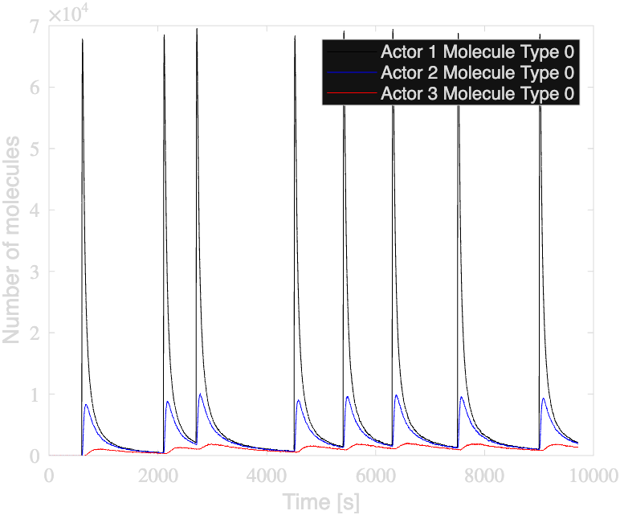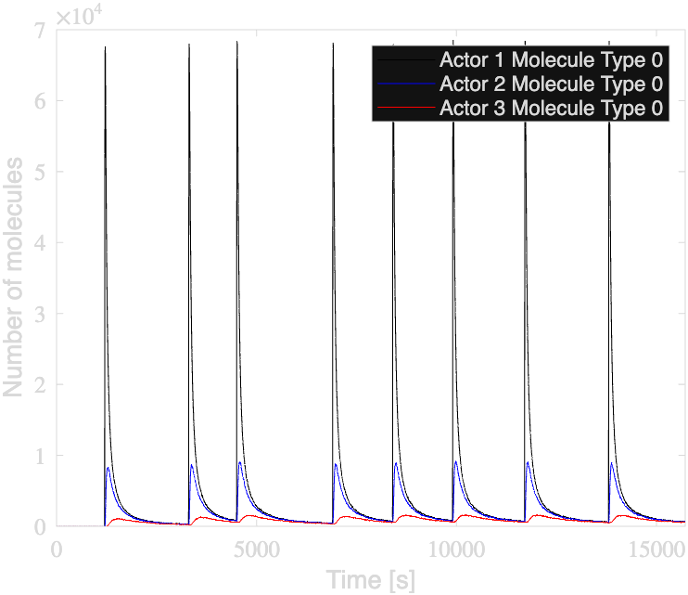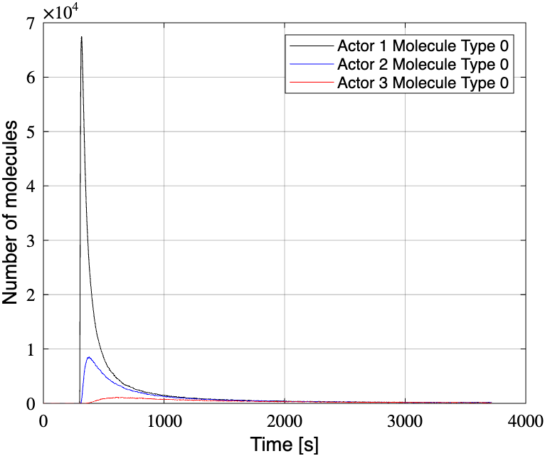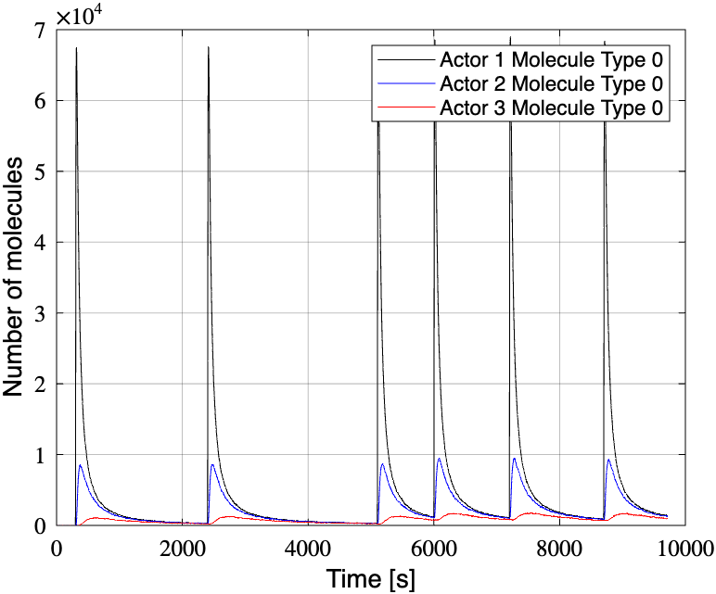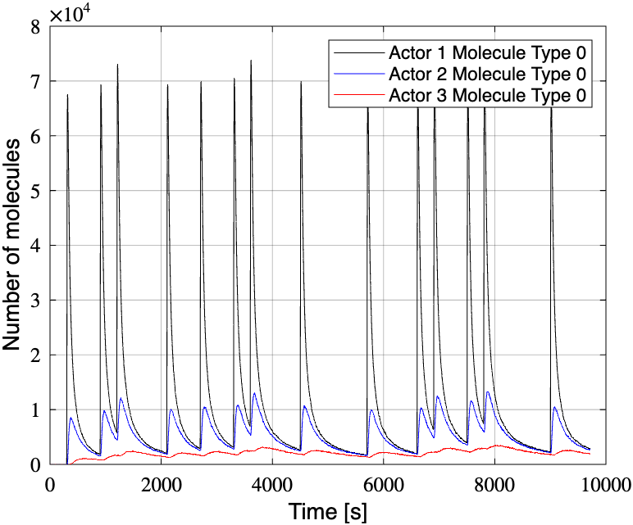

ET1 distances 5 10 15 ------ 1e6
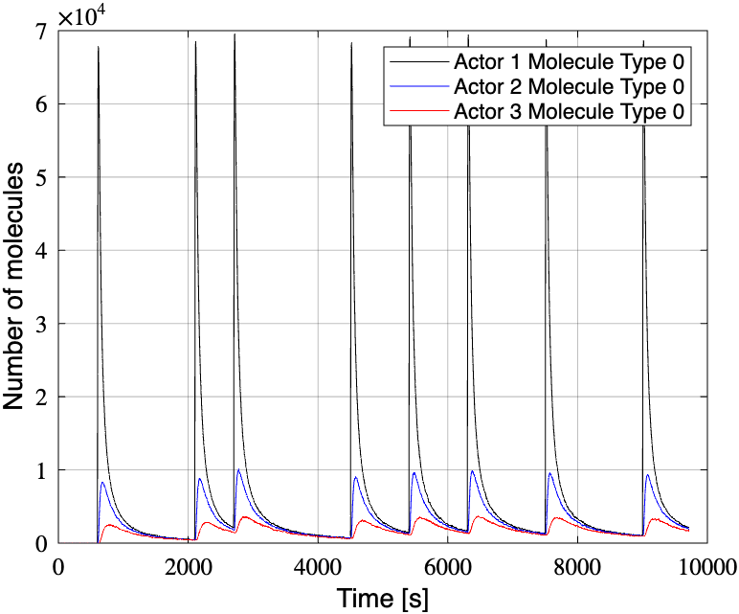

Adding three transmitters is equal to tripling the modulation strength.

Increase modulation strength/ receiver radius

Modulation Strength: 3e6

ET1 distances 5 10 15 ------ 3e6
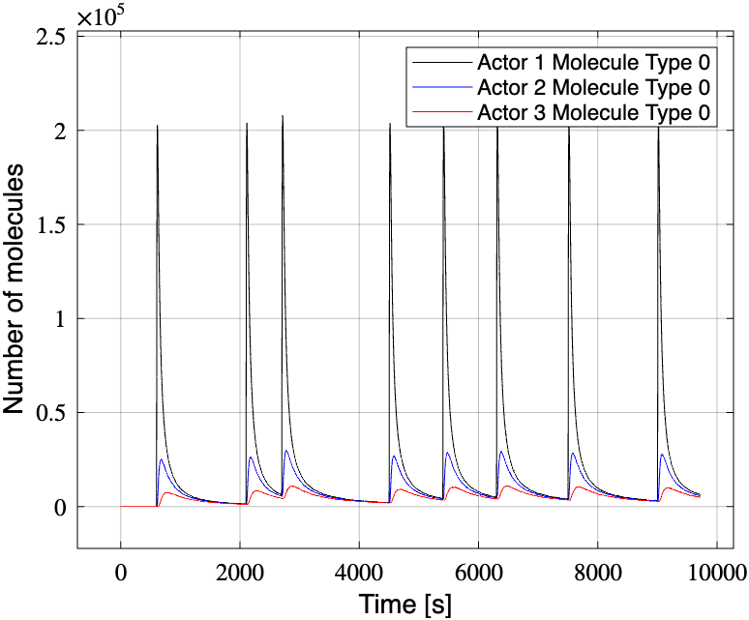

ET1 distances 10 30 50 ------ 3e6
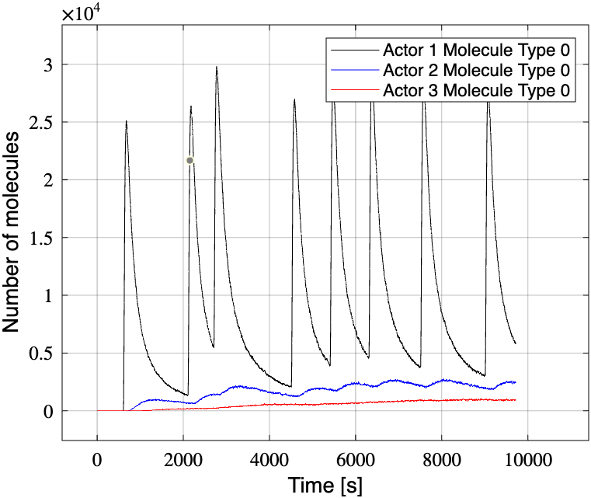

ET1 distances 10 30 50 ------ 6e6 Cannot Simulate
ET1 distances 10 30 50 ------ 4e6 -------- receiver radius 5cm
Cannot Simulate
ET1 distances 10 30 50 ------ 3e6 -------- receiver radius 5cm Cannot Simulate in 30 mins

"Outer Boundary": [0, 15e-2, 0, 5e-2] // radius 5cm instead of 3cm

ET1 distances 10 30 50 ------ 1e6 ---------- receiver radius 5cm

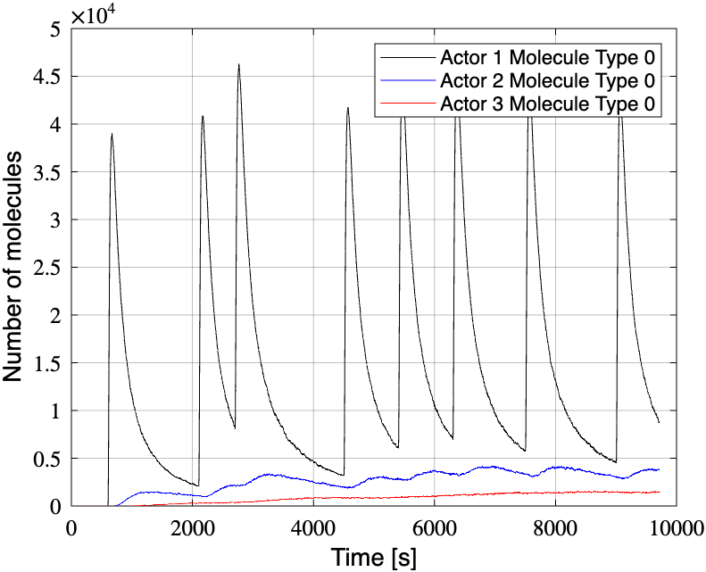

threshold detection ways

normalize the graphs/ log scale

